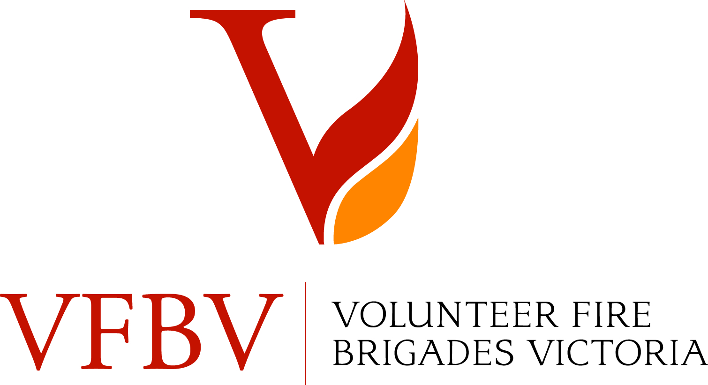

West Region Rural Championship Committee

PRESIDENT  Mr Ian Morley |  | SECRETARY  Mr Peter Loader  7 Newmarket Terrace  MINERS REST 3352  Mob: 0417 356 210  e-mail: peter.loader@members.cfa.vic.gov.au

22 December, 2022

Expressions of Interest Required Urgently

West Region Championship Committee is seeking expressions of interest for our upcoming Championships to be held at Woady Yaloak Recreation Reserve, Smythesdale on the 19 March 2023.

Can you please advise the following?

- Is your Brigade planning on competing in this event? Yes/No

- How many teams would you be entering? Senior / Junior

We are seeking this information in order to establish if it is viable to run our event, so it is vital that you let us know. If we do not have an appropriate number of competing teams the event may be cancelled.

Please email your responses by 20th January
to peter.loader@members.cfa.vic.gov.au

Entry forms will be sent out to Brigades who reply.

Peter Loader
Secretary
West Region Championship Committee.

